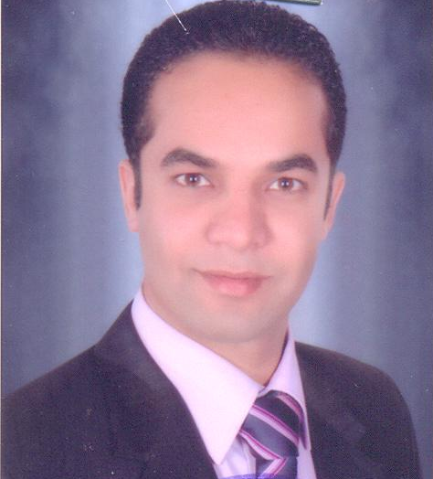
Curriculum Vitae
Personal Information:

Name: | Elhagag Ahmed Hassan Ali
Date of Birth: | 29-06-1985
Martial Status: | Married
Military Status | Exempted
Work: | Assistant lecturer at Botany and Microbiology Dept. Assiut Univ., Assiut, Egypt.
Address: | Botany and Microbiology Department, Faculty of Science, Assiut Univ., Assiut, Egypt.
E-Mail: | elhagaghassan@ymail.com
Mobile: | +2 01006317852
Contact Address | : Department of Botany and Microbiology, Faculty of Science,  University of Assiut , Assiut 71515, EGYPT  Tel. +20 88 2180665

Academic Degrees:

1. B. Sc. in (Botany), Faculty of Science, Assiut University, Egypt,
Grade: very good with honor, June 2006.
2. M. Sc. Botany (Microbiology), Faculty of Science, Assiut University, Egypt, May 2011.

Conferences:

1. The First Conference of Biological Sciences, Faculty of Science, Assiut University, March 4-5th 2009. I attended and participated in activities of this Conference.
2. The Third Conference for Young Scientists Basic Science & Technology, Assiut, Egypt 19-20 April, 2011. I had presented Oral presentation with the title: "Keratinase production by keratinolytic fungi isolated from feathers collected from chicken farms and slaughtering houses in Upper Egypt."

Training Courses:

- "Methods in Molecular Biology and its Applications in the monitoring of the Environmental stress and Ecotoxicology" from 6-10 April 2008 at Zoology department, Faculty of Science, Assiut University.
- "Applications of Biotechnology" from 12-14 April 2010 at Genetics Department Faculty of Agriculture, Assiut University.
- "The Training Workshop on HPLC and GC-Ms" from 7-8 April 2012 at Pharmaceutical Services Center (PSC), Faculty of Pharmacy, Assiut University.
- "Gene Transformation in Plants and Bacteria" through Joint Egyptian Japanese Scientific Cooperation from 1-3 Dec. 2012 at Genetic Engineering and Biotechnology Research Institute (GEBRI), Sadat City, Moneoufyia University, Egypt.

Research interests:

1. Applied Microbiology.
2. Environmental Biotechnology.
3. Microbial Genetic Engineering.
4. Biomass Energy.

Membership activities:

1- Member of Egyptian Syndicate of Scientific Professions
2- Member of The Arab Society for Plant Protection

Projects:
- Researcher in the project “biofuel production from agro-industrial wasts” awarded from Science and Technology Development Fund, 2009 (No. 1011), Egypt. The principle investigator Prof. Dr. Mohamed Hemida Abd-Alla.

Publications:
1. Koutb M.; Morsy, F. M.; Bagy, M. M. and Hassan, E. A (2012): Optimization of extracellular keratinase production by Aspergillus terreus isolated from chicken's litter. J. of advanced lab. Research in biology, 3:187-194.

2. Hassan, E. A.; Morsy, F. M.; Koutb M. and Bagy, M. M. (2012): Some studies on Keratinase activity produced by a thermotolerant Aspergillus fumigatus. Assiut Univ. J of Botany,41(1), 131-144.

3. Magdy Khalil Bagy, Mohamed Hemida Abd-Alla, Morsy FM. and Elhagag Ahmed Hassan (2014). Two Stage Biodiesel and Hydrogen Production from Molasses by Oleaginous Fungi and Clostridium acetobutylicum ATCC 824. International Journal of Hydrogen Energy. 39; 3185-3197.
4. Mohamed Hemida Abd-Alla, Magdy Mohamed Khalil Bagy, Fatthy Mohamed Morsy, Elhagag Ahmed Hassan (2014): Enhancement of biodiesel, hydrogen and methane generation from molasses by Cunninghamella echinulata and anaerobic bacteria through sequential three-stage fermentation. Energy; 78: 543-554.
5. Elhagag Ahmed Hassan, Mohamed Hemida Abd-Alla, Magdy Mohamed Khalil Bagy, Fatthy Mohamed Morsy (2015). In situ hydrogen, acetone, butanol, ethanol and microdiesel production by Clostridium acetobutylicum ATCC 824 from oleaginous fungal biomass. Anaerobe, 34:125-131.
6. Hassan A. E., Morsy M. F., Koutb M. and Bagy M. M. K. (2015) Biodegradation of chicken feathers by Chrysosporium tropicum producing plant growth promoting activity. (submitted)

Current research:
1. Research in the project “Biofuel production by bacteria from agro-industrail wastes.” awarded from Science and Technology Development Fund, 2009 (No. 1011), Egypt. The principle investigator Prof. Dr. Mohamed Hemida Abd-Alla.
2. Research in “Biodesiel production by Fungi isolated from some oleaginous plants."
Research Related Experiences:
1- Environmental Microbiology.
2- Excellent Professional in SDS PAGE in 1 Dimension & Native PAGE.
3- Excellent Professional in DNA extraction and PCR techniques.
4- Gene Transformation in Plants and Bacteria
5- Excellent Professional in the Mycotoxins extraction from fungal colonies and commodity.
5- Gas Chromatography and HPLC.

Teaching Experiences:
-Practical physiology of Fungi- Applied Microbiology- Medical mycology- Microbial toxins- phycology- Plant Kingdom- General Botany- Plant Physiology- Phytopathology an Host-Parasite relationship.

Computer Skills:

- Microsoft Excel, Microsoft Word, Microsoft PowerPoint, kaleidagraph program.

Languages:
- Arabic (maternal language).
- English (read, write, speak).

